# Interiors

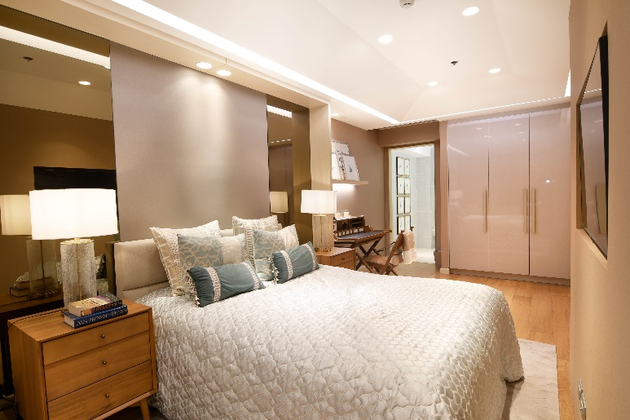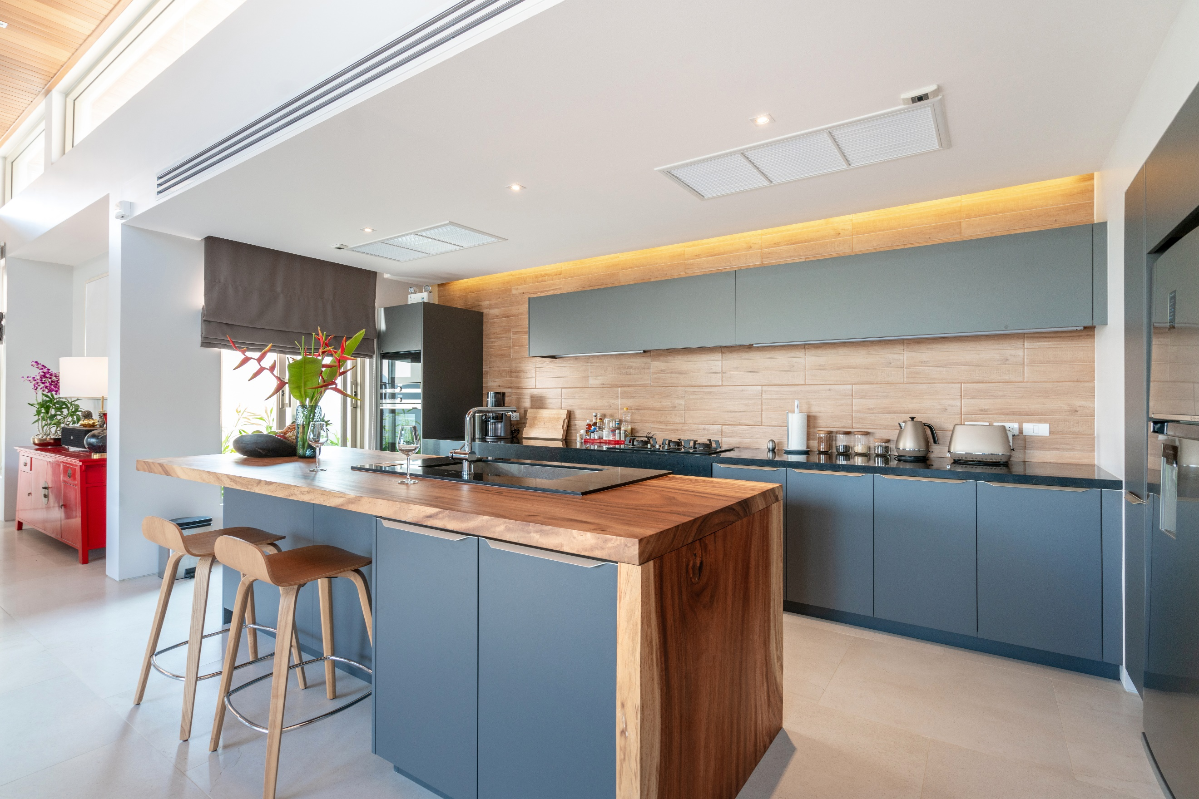

|  |  |
| --- | --- |
|  | **Kitchen -** All items such as dishes, sponges, rags should be stored away and out of sight. |
|  | **Kitchen -** Remove any magnets and papers from fridge. |
|  | **Kitchen -** Add any decorative items such as flowers, fruit bowls or hand towels. |
|  | **Bathrooms -** All personal items to be stored away and out of sight. All toilet seats down. |
|  | **Prep Bathrooms -** Decorate with new soap, hand towels and possibly a little plant. |
|  | **Floors -** Cleaned beforehand will be appreciated. |
|  | **Prep bedrooms -** Decorate with some books, new throw and new bedsheets/pillows if need be. |
|  | **Mirrors / Windows -** Please keep all mirrors and windows clean (no streaks). |
|  | **Cables / Remotes -** Please keep cables, remotes, game consoles etc... hidden away (if possible). |
|  | **Walls -** Ensure all walls are cleaned, have no markings or holes. |
|  | **Rubbish bins -** Please make sure all bins are stored away and not in view. |
|  | **Clear entryways -** Remove all items such as shoes, umbrellas or any other items from entryways. |
|  | **Fans** - Turn off all ceiling fans and hide any portable fans (inside the garage is a good place). |
|  | **Turn on all lights** - Please ensure that all lights are working and replace any that’re broken. |
|  | **Photo frames -** Remove all personal/family photo frames. Artwork such as painting is accepted. |

# Exterior

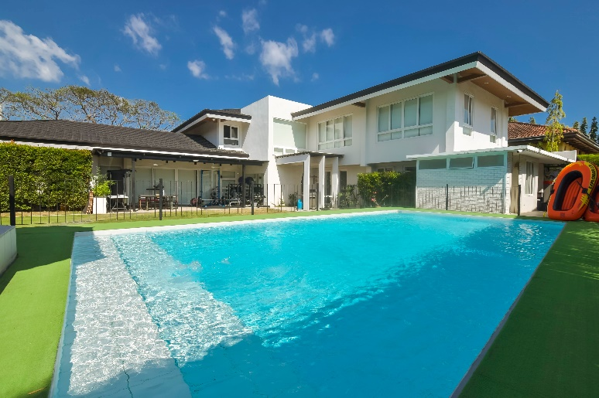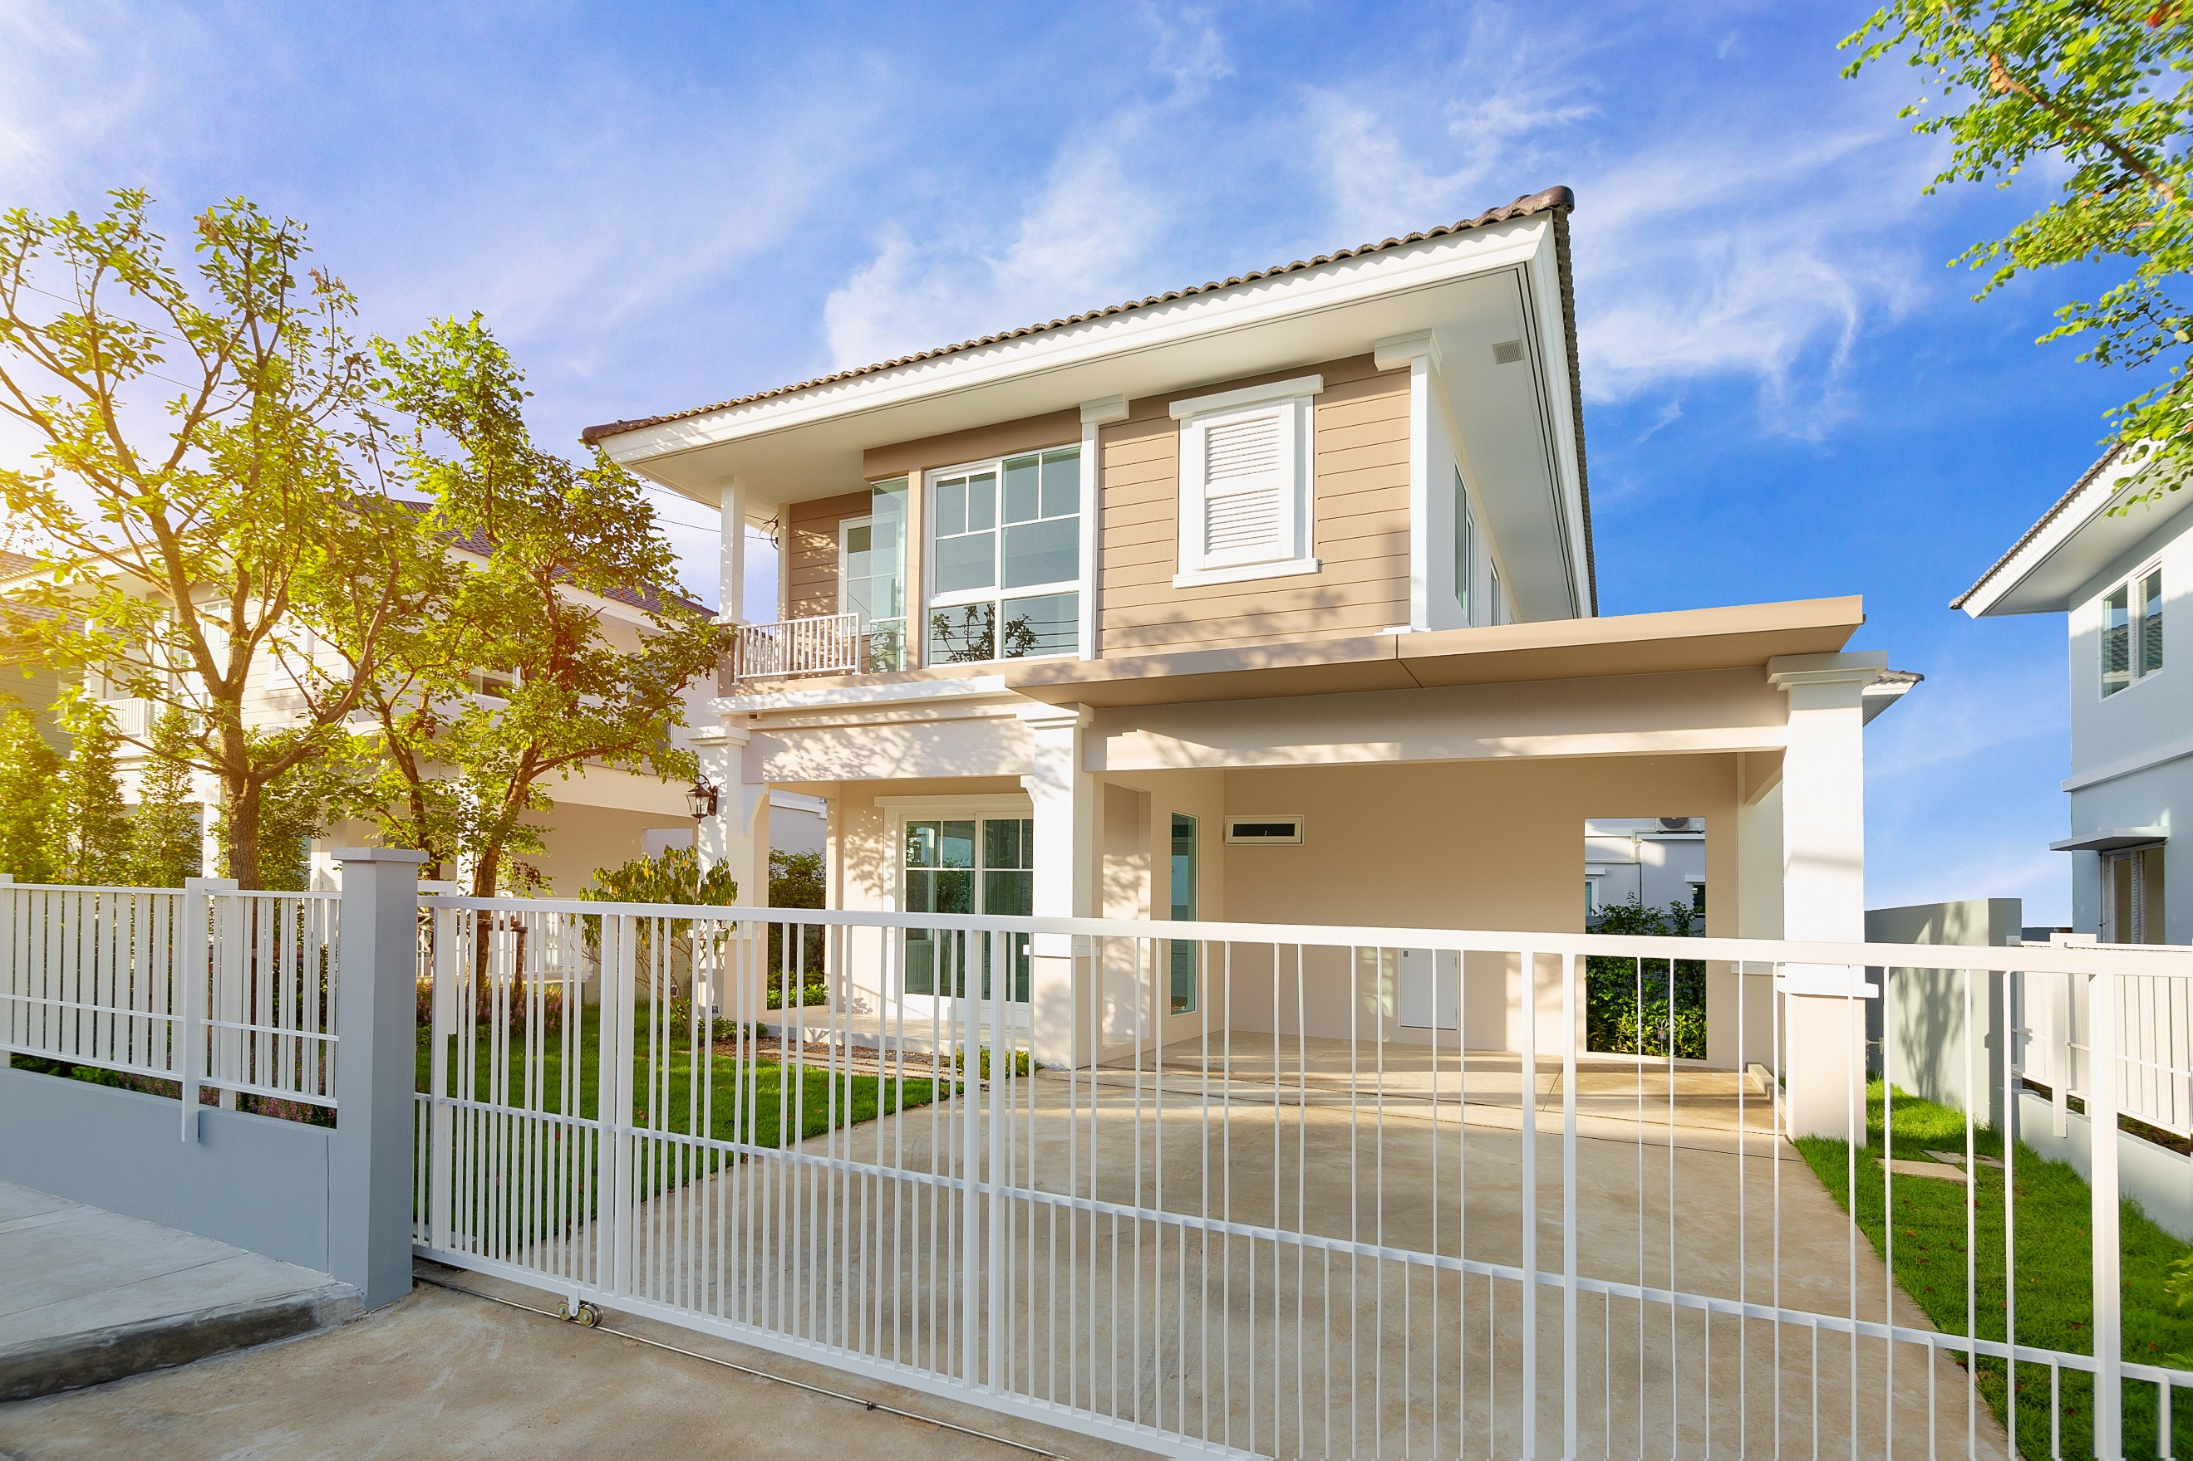

|  |  |
| --- | --- |
|  | **Lights -** All lights to be changed if need be. |
|  | **Cars -** Store cars in garage or even park further away from the house. |
|  | **Driveway -** Keep driveway completely empty and clear. |
|  | **Bins -** Put bins away in the garage. |
|  | **Grass -** Mow the lawn a day before. |
|  | **Toys -** No toys to be left outside anywhere (kid’s toys, animal toys or any kind) |
|  | **Pool -** No pool covers, pool cleaners or pool toys in sight. Remove all. Clean pool a day before. |
|  | **Gardening -** Rake all leaves and ensure all plants are healthy. |
|  | **Clothes Line -** Ensure no clothes are on the line - even better if you can retract/hide the line. |
|  | **Hoses -** Please make sure there are no hoses in sight. Remove them completely. |
|  | **Clear entryways -** All entryways to be kept 100% clear. |

**If you’re unsure on anything else that needs to be done, please contact me prior to the photoshoot and I’ll assist you.**

**Remember that the more you do in order to prepare your home for the photoshoot, the better the overall quality and higher chances of attracting home buyers.**